[TITLE]
The Self as Subject and Method: Artistic Practice as Autoethnography

[PARA 1]
Autoethnography, as defined in Adams, Bochner and Ellis (2011, 273) is a qualitative “approach to research and writing that seeks to describe and systematically analyze personal experience in order to understand cultural experience”. It is a definition originally written to characterise the actions and goals of anthropological researchers, but I would moot that it’s a definition that equally characterises the practice of many – if not most – contemporary artists, including my own. When viewed through the lens of this definition, artistic practice emerges not just as creative output, but a legitimate form of autoethnographic research that embodies the artist as ‘researcher-as-instrument’, who interrogates cultural phenomena through their personal narrative and aesthetic expression. (121)

[PARA 2]
This critical review will explore how artistic practice functions as autoethnography by fulfilling its primary methodological requirements: the systematic exploration of personal experience, the relationships between the individual and cultural contexts, and the use of reflexive investigation to generate knowledge. Through exploring the theoretical foundations, methodological parallels, and practical realisations of art in relation, I will show how merging research, and creative expression qualifies the artistic practice of many contemporary artists as a valid form of autoethnographic research, an important means of ‘knowing’ the world around us. (87)

[PARA 3]
The Theoretical Foundations: Autoethnography and Artistic Enquiry
Traditional ethnography separates the objective researcher from their subjects of study. But in the 1960’s the ethno-psychiatrist, Georges Deveraux proposed “that observers in the social sciences had not yet learned how to make the most of their own emotional involvement with their material…the subjectivity of the observer…influences the course of the observed event” (Behar, 1996, 6). As Behar rationalises throughout the “Vulnerable Observer” this false dichotomy between the objective researcher and subjective experience is effectively constraining valuable enquiry. Autoethnography dissolves this separation by positioning the researcher’s lived experience as both xsubject of exploration, and the vehicle through which cultural understanding is developed. (109)

[PARA 4]
Historically, artistic practice has also functioned as a form of cultural enquiry, with artists acting as both subjects and interpreters of their social contexts. From the Romantics emphasis on freedom of expression, the Futurists’ rejoicing of the technological triumph of the early 20th Century, to Basquiat’s incisive critiquing of the persistence of colonial attitudes and Tracy Emin’s confessional vulnerability – all show how artistic practice is in natural alignment with autoethnographic principles. These – and many other contemporary practitioners - do not merely create aesthetic objects: they systematically explore their personal experience to reflect on broader cultural phenomena. (96)

[PARA 5]
In his book “Art Practice as Research: Inquiry in Visual Arts”, Graeme Sullivan argues that “artistic inquiry involves a process of creating meaning that yields insights not accessible through other research processes.” (Sullivan, 2010, 41). This creation of meaning through artistic practice mirrors autoethnography in its emphasis on experiential knowledge production, where the reflexive examination of lived experience rather than objective observation leads to the creation of meaning. (68)

[PARA 6]
Methodological Parallels: Process as Research
When examining the emphasis on process, reflexivity and narrative construction in both artistic practice and autoethnography, methodological parallels become apparent. In both, sequential, predefined, research paths are dismissed in favour of emergent, iterative processes through which meaning develops from practice and reflection. (47)

[PARA 7]
Both artists and autoethnographers share reflexive stances. Leon Anderson emphasises the importance of “analytic reflexivity” in relation to autoethnography – “At a deeper level, reflexivity involves an awareness of reciprocal influence between ethnographers and their settings and informants. It entails self-conscious introspection guided by a desire to better understand both self and others through examining one’s actions and perceptions in reference to and dialogue with those of others.” (Anderson 2006, 382). Reflexivity is inherent in artistic practice, as artists continually negotiate between their internal experiences and external cultural contexts. The studio is the situation for reflexive enquiry, offering a space where materials, processes and personal narratives intersect, generating new understandings. (109)

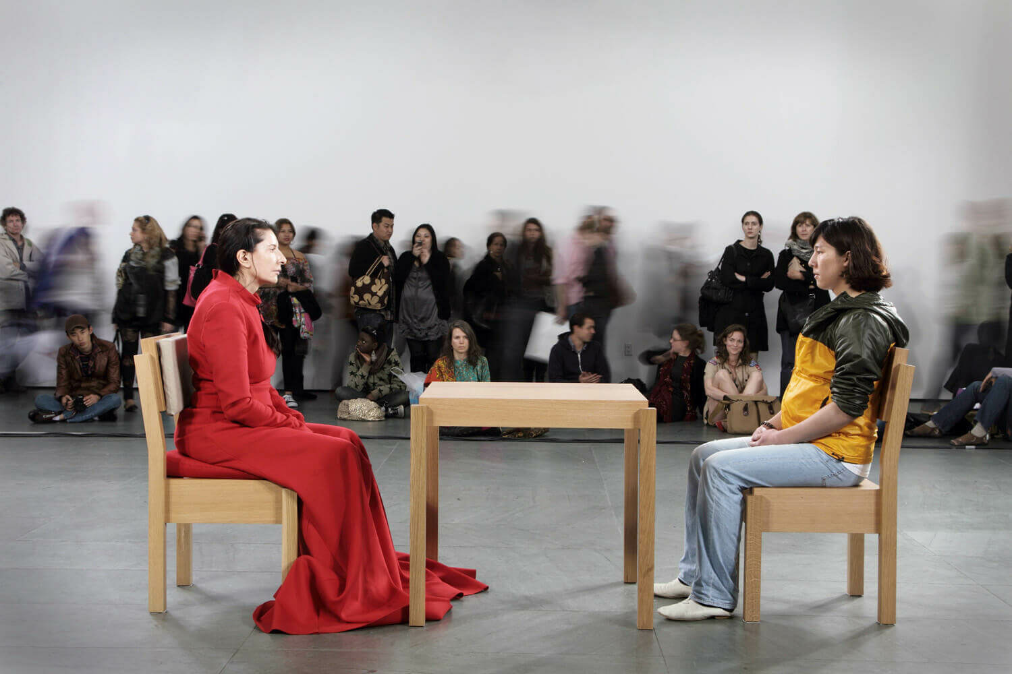
Fig.1. The Artist is Present (2010)

[PARA 8]
Consider the work of Marina Abramaović, whose interdiscipinary research-based practice explores the possibilities and limitations of the human mind and body, the performer-audience relationship and how the complexity of the present time can shift awareness and consciousness of human beings (MAI, 2025). Abramović’s practice “represents an effective and powerful example of the body-as-a-text in which subjectivity can be re-expressed and reinvented…that results in a redefinition of a subjective and, simultaneously, collective experience of identity’. (Demaria 2004, 295). Abramović’s process is an embodied approach to knowledge production, which reflects autoethnography’s emphasis on experiential understanding, whilst utilising artistic methods as research tools. (100)

[PARA 9]
Artistic documentation and analysis further reflect autoethnographic methodologies. Sketchbooks, research journals, photographic records – all mirror the fieldnotes of traditional ethnography. These are documents that capture the evolution of aesthetic ideas, cultural contexts, personal reflections and analytical insights that inform the creation of work. Where artists such as Rachel Whiteread discuss their work in artist statements, interviews or catalogues, they are engaging in analytical reflection that characterises autoethnography. (67)

[PARA 10]
Cultural Analysis through Personal Narrative
Autoethnography’s role is to connect personal experience to cultural phenomena, as a means of generating knowledge. As Chang explains about autoethnography, it is “autobiographies that self-consciously explore the interplay of the introspective, personally engaged self with cultural descriptions mediated through language, history and ethnographic explanation” (Ellis and Bochner, 2000:742 cited in Chang, 2008:46). Similarly, artistic practice grounds cultural analysis in personal narrative, whilst employing systematic creative methods to surface insights. (75)

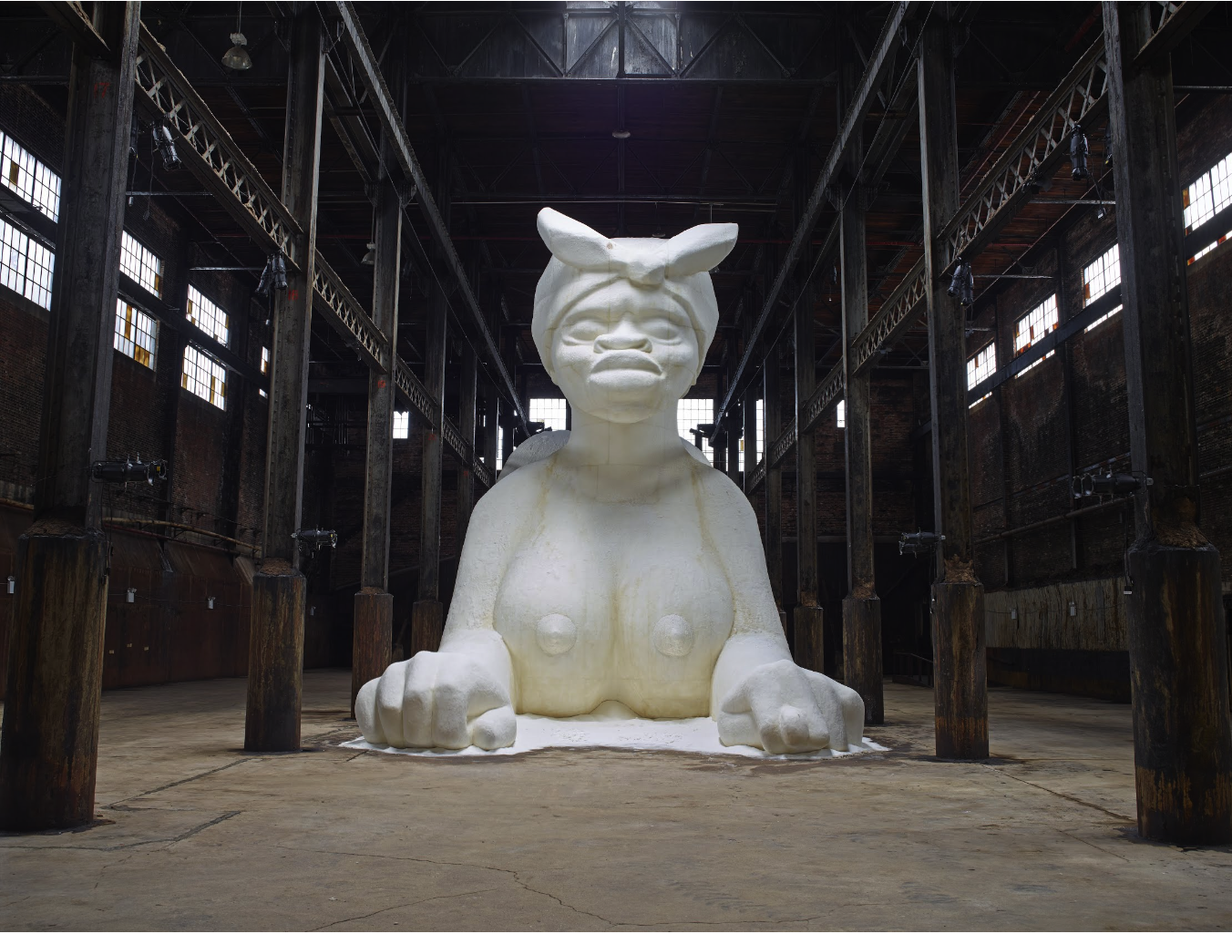
Fig.1. A Subtlety (2014)

[PARA 11]
Take the example of Kara Walker’s work. Her silhouette installations reflect on the legacy of slavery and racial violence through her personal experiences as a Female artist of colour. “A Subtlety” (2014), her massive sphinx-like sugar sculpture, installed in the Domino Sugar Factory connects her personal experiences of racial and gender stereotypes to the historical and economic systems that perpetuated slavery. Using personal experience as a lens for analysing cultural phenomena and generating new knowledge about racial hierarchies in contemporary society, Walker’s practice can be seen as functioning as autoethnographic research. [91]

[PARA 12]
Challenges and Critiques: Rigour and Validity
Criticism of both autoethnography and practice-based research is centred around their scholarly validity and rigour in comparison to traditional research methods. The systematic analysis privileged for knowledge production can appear to be compromised by the subjectivity of personal experience and the aesthetic dimensions of artistic practice. These critiques though are typical of narrow, institutionalised concepts of research that declare certain forms of knowledge production as more valid.
[73]

[PARA 13]
Autoethnography’s validity lies not in its adherence to traditional research but in the way it exercises “research as a political, socially-just and socially conscious act” (Adams and Holman-Jones, 2008 cited in Adams, Bochner and Ellis, 2011:273). Similarly, artistic practice achieves validity through its ability to surface insights that would be inaccessible through other methods. Embodied knowledge produced from artistic practice, the cultural critique contained within aesthetic choices and the reflexive analysis in all artist statements are all valid as autoethnographic enquiry. [81]

[PARA 14]
Conclusion
Artistic practice should be considered as a valid form of autoethnography as it systematically explores personal experience to understand cultural phenomena, uses reflexivity to generate knowledge and connects individual narratives to wider social contexts. By considering the theoretical foundations, methodological parallels and practical applications I hope to have shown that artists who engage in reflexive creative practice are engaging in a research methodology that generates valuable and valid knowledge. (70)

[PARA 15]
Instead of dismissing artistic practice as a valid form of ethnographic research it should be appreciated as an opportunity for expanding our methods for knowledge production: artists have always examined their social environments, by combining their lived experience and creative methodologies to generate insights. Autoethnography offers a framework for recognising and validating knowledge production, whilst artistic practice offers innovative means for conducting the enquiry. (64)

[PARA 16]
Recognising artistic practice as autoethnography has significant implications for both fields, expanding our definitions of legitimate research methodologies, whilst enhancing artistic practice with scholarly frameworks for enquiry. By challenging disciplinary boundaries, the merging of artistic practices and autoethnographic methodology will deliver promising directions for knowledge production that honour the multi-dimensional nature of human experience. [54]

Bibliography
Adams, E., Bochner, A., Ellis, C. (2011) 'Autoethnography: An Overview' In: Historical Social Research 36 (4) pp.273-290
Barrett, E., and Bolt, B,. (eds) (2010) Practice as Research: Approaches to Creative Arts Enquiry London: I.B.Tauris
Behar, R (1996) The Vulnerable Observer: Anthropology that Breaks your Heart. Boston: Beacon Press
Chang, H (2008) "Chapter3: Autothenography' In: Autoethnography as Method California: Left Coast Press pp.43-57
Demaria, C (2004) 'The Performative Body of Marina Abramović. Rerelating (in) Time and Space' In European Journal of Women's Studies 11 (3)
Fine, G., Rotheburg, J. (2008) 'Art Worlds and their Ethnographers' In: Ethnologie Francaise 38 (1) pp.31-37
Hackett, P., Schwarzenbach, J., Jürgens, U. (2016) 'Chapter 13: Autoethnography' In: Consumer Psychology: A Study Guide to Qualitative Research Methods. Germany: Verlag Barbara Budrich pp.97-90.
Hodges, B.D., Kuper, A., Reeves, S., (2008) 'Qualitative Research: Qualitative Research Methodologies: Ethnography' In: British Medical Journal 337 (7668) pp.512-514
Marina Abramović Institute (MAI) (2025) About Marina Abramović Institute At: http://mai.art/about (Accessed 15/06/25)
Sullivan, G (2009) Art Practice as Research: Inquiry in Visual Arts (2nd ed.) London: Sage Publications

List of Illustrations
Fig.1. Abramović, M (2010) The Artist is Here [Performance] At: https://www.lissongallery.com/artists/marina-abramovic (Accessed 15/06/25)
Fig.2. Walker, K. (2014) A Subtlety [Sculpture] At: https://artsandculture.google.com/asset/a-subtlety-kara-walker/TAEOFCFww_WbDg?hl=en-GB (Accessed 15/06/25)

